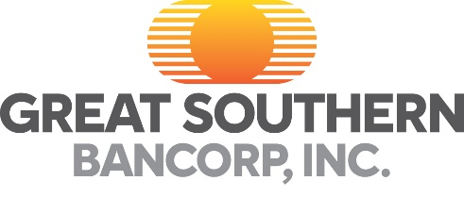

September 4, 2024

Reporters May Contact:
Kelly Polonus, Great Southern Bank, 417-895-5242
kpolonus@greatsouthernbank.com

Great Southern Bancorp, Inc. Announces
Third Quarter 2024 Preliminary Earnings Release Date and Conference Call

SPRINGFIELD, Mo. – Great Southern Bancorp, Inc. (NASDAQ:GSBC), the holding company for Great Southern Bank, expects to report third quarter 2024 preliminary earnings after the market closes on Wednesday, October 16, 2024, and host a conference call on Thursday, October 17, 2024, at 2:00 p.m. Central Time (3:00 p.m. Eastern Time).

The call will be available live or later in a recorded version at the Company’s Investor Relations website, https://investors.greatsouthernbank.com.

Participants may register for the call here. While not required, it is recommended that participants join 10 minutes prior to the event start. Instructions are provided to ensure the necessary audio applications are downloaded and installed. Users can obtain these programs at no cost.

The Company will notify the public that third quarter 2024 results have been issued through a news release and will post the results to the Company’s Investor Relations website. The earnings release will also be available on the Securities and Exchange Commission’s (SEC) website, www.sec.gov, as an exhibit to a Current Report on Form 8-K that will be furnished by the Company to the SEC.

With total assets of $6.0 billion, Great Southern offers a broad range of banking services to commercial and consumer customers. Headquartered in Springfield, Missouri, the Company operates 89 retail banking centers in Missouri, Iowa, Kansas, Minnesota, Arkansas and Nebraska, and commercial loan production offices in Atlanta; Charlotte, North Carolina; Chicago; Dallas; Denver; Omaha, Nebraska; and Phoenix. Great Southern Bancorp is a public company and its common stock (ticker: GSBC) is listed on the NASDAQ Global Select Market.

www.GreatSouthernBank.com

