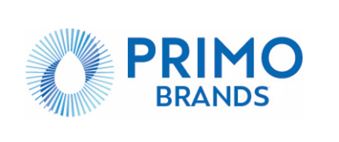

Disclosure of Amendments to the Code of Business Conduct and Ethics
On July 31, 2025, the Board of Directors (the “Board”) of Primo Brands Corporation (the “Company”) adopted an amended Code of Business Conduct and Ethics (the “Code”) applicable to the employees, officers and directors of the Company. Among other changes, the amended Code:
- addresses changes in law and jurisdiction of operation;
- updates the Company’s mission and values; and
- provides additional details regarding the Company's environmental sustainability strategy, including specific initiatives like water stewardship, circular packaging, and climate action.
Other changes to the Code include changes of a technical, administrative and non-substantive nature. The Code, as amended, has been posted to the “Governance Documents” section of the “Governance” page of the Company’s investor relations website (https://ir.primobrands.com). The amendments to the Code do not result in any waiver, explicit or implicit, from any provision of the Code as in effect prior to the Board’s actions to amend the Code.
********

